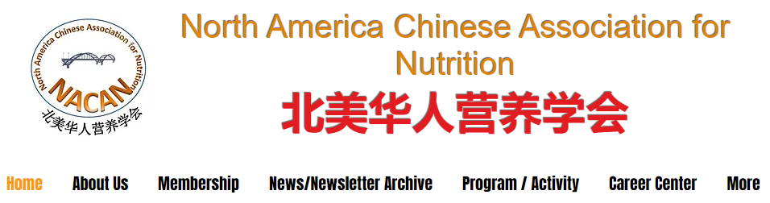

NACAN Fall Newsletter
October 2023

Message From the President
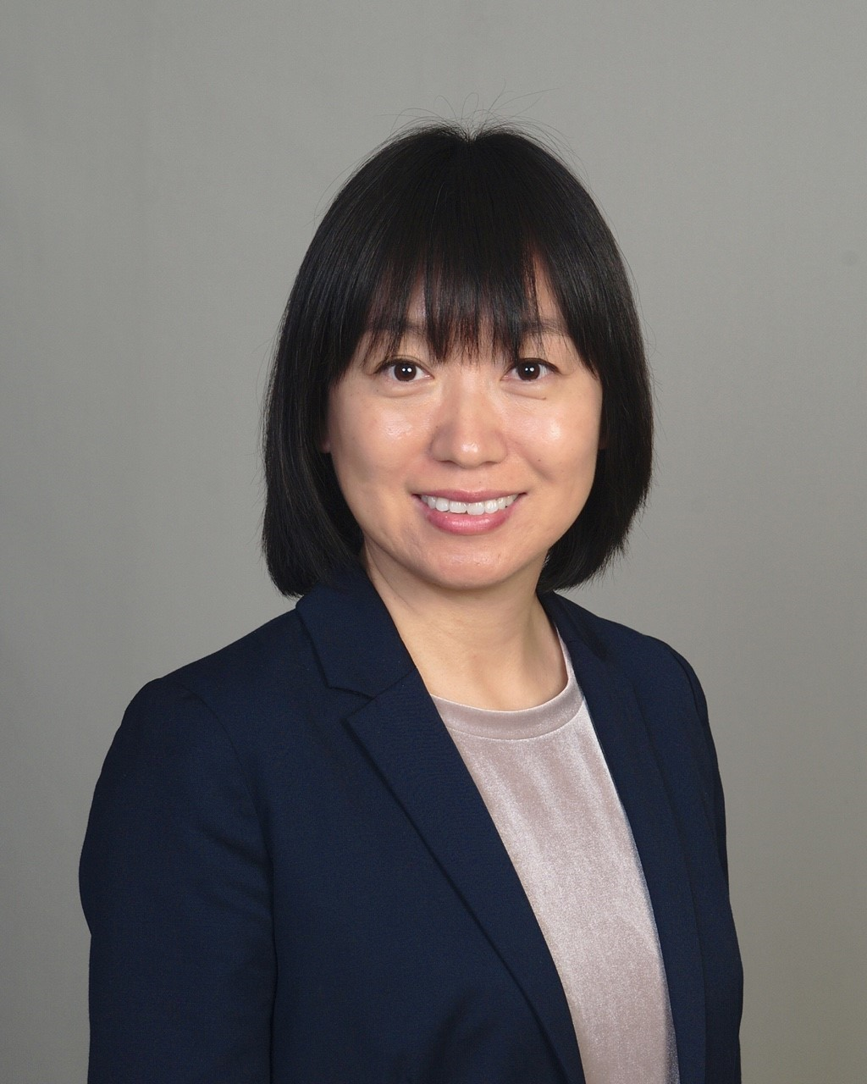
Dear NACAN family members,
It is my great pleasure to welcome everyone to the new 2023-2024 term! Thank you for your continued membership and support of our organization – North America Chinese Association for Nutrition (NACAN). Only with your help, we can dedicate our efforts to achieving our mission in promoting scientific exchange in nutrition and food industry, education, networking, and collaboration.
I would like to express my gratitude and appreciation to our previous presidents and the past leadership team members for their dedications and commitment for NACAN. I am humbled to follow their footsteps and will continue to serve our NACAN members and extended scientific community to the best of my ability.
Congrats and welcome new/existing members to the 2023-2024 leadership team. We have a talented, passionate, and dedicated team. Looking ahead, we are already hard at work planning and creating events, activities, and training for 2023-2024. More specifically, we are committed to focus on these four areas this year.
- Growth and member benefits
  - We are determined to identify and provide more member benefits to our members.
- Training and Education
  - We will continue running cutting-edge scientific programs to provide training and education opportunities.
- Collaborations
  - We strive to continue our collaborations with current collaborators and develop new collaborative relationships with more organizations, societies, universities, and companies in the North America, China, and worldwide.
- Mentoring and Professional Development
  - NACAN will help make the connections between young and senior members and establish mentor/mentee relationships based on your scientific and career interests.
I invite all our old friends and new friends to continue supporting NACAN and get involved in the new term. Please feel free to reach out if you have any feedback, comments, and ideas. I look forward to hearing from you and meeting you at our events/activities this year. I wish all of you a great and productive academic year!
Sincerely,
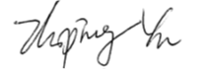
Zhiping Yu, PhD, RDN, LDN, FAND
Associate Professor, University of North Florida
NACAN president (2023-2024)

October 2023 Issue NACAN Newsletter

N Member Benefits and Offers
NACAN 2023-2024 Leadership Team

Board of Director  Chaodong Wu, Texas A&M University  Zhiping Yu, University of North Florida  Lei Hao, Indiana University of Pennsylvania  Guoxun Chen, Huazhong Agricultural University  Zhi Chai, Icahn School of Medicine at Mount Sinai  Officers  Guoxun Chen – Past President; Huazhong Agricultural University  Ling Zhao – Past President, Teller; University of  Tennessee at Knoxville  Jinrong Zhou – Past President; Harvard University  Chaodong Wu – Past President; Texas A&M  University  Zhiping Yu – President; University of North Florida  Lei Hao – President-Elect; Indiana University of  Pennsylvania  Linglin Xie – Secretary; Texas A&M University  Sheau Ching Chai – Treasure; University of Delaware  Scientific Program Committee  Zhenhua Liu – Chair; University of Massachusetts  Amherst  Shelly Xu – Co-Chair; Nestle Health Science  Tianou Zhang - University of Texas at San Antonio  Hao Wu – Shandong University  October 2023 Issue NACAN Newsletter | Communication Committee  Lirong Shen – Chair; Zhejiang University  Jie Zhu – Co-Chair; Texas State University  Bianca Xu – University of Illinois Urbana-Champaign  Membership Committee  Libo Tan – Chair; The University of Alabama  Rui Li – Co-Chair; Wuhan University  Career and Professional Development Committee  Dongmin Liu – Chair; Virginia Tech  Xinge Zhang - The Chinese University of Hong Kong  Continue Education Committee  Carol Liu – Chair; Texas Children’s Hospital  Yang Li – CVS Health

The 5th Annual Symposium Recap

By Lei Hao
The Fifth NACAN Summit Frontiers in Nutrition held online from July 28-30, 2023, was a remarkable event that brought together a staggering 60,000+ attendees. Organized by the North America Chinese Association for Nutrition (NACAN) and co-sponsored by the University of Science and Technology of China, Huazhong Agricultural University, and Fudan University, this symposium aimed to explore various facets of nutrition and its impact on health and well-being.
Session 1: Nutrition Epidemiology and Non-communicable Diseases
This session was chaired by Drs. Lei Hao and Wei Bao. It delved into the intricate relationship between nutrition and non-communicable diseases. Attendees had the opportunity to explore epidemiological aspects, risk factors, and interventions related to nutrition and its role in preventing and managing non-communicable diseases.
Session 2: Foods and Nutrition
The second session was chaired by Drs. Shelly Xu and Guoxun Chen. It focused on the science of food and its profound effects on human health. Discussions revolved around topics such as dietary patterns, nutrient composition, food bioactive compounds, and their influence on health outcomes.
Session 3-A: Exercise, Nutrition, and Human Health
This session was chaired by Drs. Tianou Zhang and Ling Zhao. In this session, attendees delved into the effects and underlying mechanisms of exercise and nutrition on human health. The role of exercise, physical activity, and nutrition in promoting health, preventing diseases, and enhancing overall well-being were extensively discussed.
Session 3-B: Nutrition and Health: Epidemiological and Molecular Aspects
This session was chaired by Drs. Sheau Ching Chai and Yang Li. Experts explored the roles of vitamins and minerals in metabolic syndrome, aging, and cardiometabolic diseases in this session. Regulatory proteins involved in energy metabolism and chronic diseases were also discussed.
Session 4: Nutrition in Cognitive Function and Mental Health
The final session was chaired by Drs. Zhi Chai and Zhiping Yu. It explored the intricate relationship between nutrition and mental health, cognition, and brain function. Experts shed light on how nutrition impacts mental well-being, fostering a deeper understanding of this complex interplay.
Throughout the symposium, Dr. Chaodong Wu, the president of NACAN, provided a warm introduction, setting the tone for the event. Dr. Zhiping Yu, the new president of NACAN, concluded the symposium by summarizing the key takeaways and expressing anticipation for the meeting in the coming year.
This symposium featured more than 30 prestigious speakers from China and the United States, who delivered insightful and informative presentations. Particularly guest presentations by Dr. Wendong Huang, President of Chinese American Diabetes Association and Dr. Yanqiao Zhang, Incoming President of Chinese American Liver Society, added to the event's significance. The overarching theme of the event, "Nutrition for a Healthy Life: Maximizing Health through Fostering Optimal Nutrition and Lifestyle Behaviors," resonated throughout the sessions, inspiring attendees to prioritize nutrition and make informed lifestyle choices.
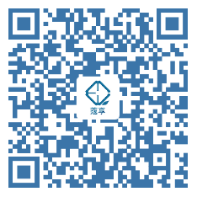
The Joint Nutrition Scientific Symposium in 2023 was a resounding success, fostering knowledge sharing, collaboration, and a deeper understanding of the critical role nutrition plays in human health. Attendees left the event with a wealth of insights and a renewed commitment to promoting health through optimal nutrition and lifestyle behaviors. We look forward to another fruitful symposium in the coming year.

To access the recordings of presentations, please check the link and QR code below:
https://www.koushare.com/topicIndex/i/NACAN2023

October 2023 Issue NACAN Newsletter

NACAN Members Benefit & Offers

By Libo Tan and Rui Li
NACAN, the North America Chinese Association of Nutrition, offers an array of exclusive benefits to its members that enhance their professional growth and networking opportunities in the field of nutrition.
These member-exclusive advantages encompass:
- Invitations to Prestigious Events: Members receive exclusive invitations to seminars, conferences, and workshops, featuring distinguished experts in the nutrition field. These events offer invaluable insights and foster collaborative opportunities.
- Networking and Career Advance: 1) Members have access to the online NACAN Member Directory. 2) NACAN regular members can post job advertisements through various platforms at no charge. 3) NACAN offers a Mentor-Mentee program, providing members with the chance to engage in mentorship relationships that facilitate personal and professional growth.
- Awards and Competitions: NACAN members are eligible to apply for small grants, prestigious awards and participate in nutrition-related competitions, showcasing their research or work.
- Visibility in Media: Members have the opportunity to gain visibility through features in the association's newsletter and/or WeChat official account, promoting their achievements to a broader audience.
- Participation in Governance: As members, individuals can vote for leadership roles within NACAN, helping shape the future direction and initiatives of the organization. Members also have the privilege to serve as committee members.
- Education Resources: Members can gain Continue Professional Education (CPE) credits through attending NACAN-sponsored events.
NACAN is delighted to announce a limited-time membership promotion for November 2023! During this special period, individuals who apply for NACAN membership will enjoy a 50% discount on the membership fee. For existing members – we appreciate your support in spreading the word about our association. For each colleague or friend you refer to join NACAN in November, you'll receive a 30% discount when you renew your membership in January as our token of gratitude.

To join NACAN, please 1) contact us at nacanmembership@gmail.com for the application form and 2) send your membership fee to nacanbill@outlook.com via Zelle if you are in the U.S. or via WeChat transfer (ID: tanlibo62) if you are in China.

October 2023 Issue NACAN Newsletter

Recent Outstanding Publications of NACAN Members

By Jie Zhu

Hepatocyte Adenosine Kinase Promotes Excessive Fat Deposition and Liver Inflammation.
Honggui Li, Juan Zheng, Qian Xu, Yongjian Yang, Jing Zhou, Xinlei Guo, Yongfeng Cai, James J Cai, Linglin Xie, Joseph Awika, Xianlin Han, Qingsheng Li, Lindsey Kennedy, Heather Francis, Shannon Glaser, Yuqing Huo, Gianfranco Alpini, Chaodong Wu
Gastroenterology. 2023 Jan;164(1):134-146. Doi: 10.1053/j.gastro.2022.09.027.

- Main Findings: Hepatocyte adenosine kinase (ADK) triggers or exacerbates the pathogenesis of nonalcoholic fatty liver disease (NAFLD) by promoting excessive fat deposition and liver inflammation through suppressing hepatocyte fatty acid oxidation and producing hepatocyte-derived proinflammatory mediators.

- Meaning: The study validates the feasibility of ADK inhibition as a novel therapeutic strategy for NAFLD.

Anti-fatigue and anti-oxidant effects of curcumin supplementation in exhaustive swimming mice via Nrf2/Keap1 signal pathway
Yong Chen, Jiajun Wang, Ziheng Jing, Jose M Ordovas, Jing Wang, Lirong Shen
Curr Res Food Sci. 2022 Jul 16;5:1148-1157. Doi: 10.1016/j.crfs.2022.07.006.

- Main Findings: Curcumin supplementation alleviated exercise-induced oxidative stress and significantly enhanced the activities of superoxide dismutase, catalase, and glutathione peroxidase by activating the Nrf2 signaling in exhaustive swimming mice.

- Meaning: The findings provide additional evidence supporting the use of curcumin as functional food, especially by those engaged in sports-related activities.

